Edu 402 final paper spring 2020

Integrated curriculum design
An integrated curriculum is described as one that connects different areas of study by cutting across subject-matter lines and emphasizing unifying concepts. Integration focuses on making connections for students, allowing them to engage in relevant, meaningful activities that can be connected to real life. Can you imagine how an integrated curriculum can benefit your students? Understanding the benefits and how to effectively integrate curriculum can help teachers and students become more successful in the classroom.
Inductive thinking drawing generalizations from several items of specific data
Deductive thinking Involves applying one or more generalizations to specific cases.
Principles of designed curriculum
Teachers approach curriculum in purposeful and intentional ways, designing learning experiences that are relevant, meaningful and support students to acquire the knowledge, skills and competencies necessary to prepare them for their futures.
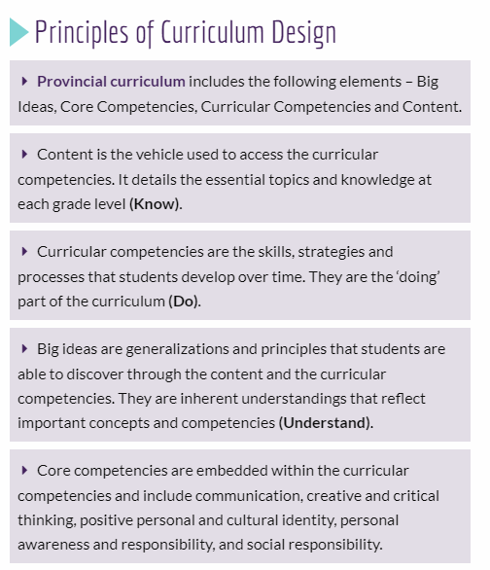

Steps of organizing curriculum
Elements for organizing curriculum
‘Place value’ it could be one element for:
- Organizing curriculum

- Integration in LEs in various subject areas; like for application in social studies, science & while shopping
Tyler’s theory:

Tyler’s (1949) / Technical Paradigm:
This theory is dominated curriculum theory for a number of decades.
This theory strongly influences curriculum planning in schools even today.
Tyler’s (1949) questions parameters for curriculum study are:
1) What educational purposes should the school seek to attain?
2) How can learning experiences be selected which are likely to be useful in attaining these objectives?
3) How can learn experiences be organized for effective instruction?
4) How can the effectiveness of learning experiences be evaluated?

Source Plan
It is preliminary flexible plans for teaching. It provides a collection of possible materials for teachers
Characteristics of Source Plan
1. Flexible – can be modified.
2. Inclusive – wide range of experiences.
A teacher can select material of her choice from the source unit as per the requirements of a particular group and use for teaching in her class.
Teachers Involvement in Curriculum Development
Teachers’ involvement
Teachers become extensively involved in curriculum development as they write down precise instructional objectives for their classrooms based on general goals.
What are instructional objectives?
Instructional objectives are clearly stated & describe observable & measurable student behaviors
What is included in Instructional Objectives?
- Behaviors
- observable
- measureable

- condition under which behaviors will occur
- on an exam
- in a classroom

A minimum / acceptable level of performance

(%age of correctness)
Expertise required among teachers to translate goals into instructional objectives
The knowledge about:
- goals
- subject matter &
- students

Evaluation Procedure Steps
Evaluation Procedure Steps:
- Defining objectives
- Identifying situations
- Selecting and developing instrument
- recording evidence
- summarizing records of learn
Curriculum design:
Curriculum Designs
Organization of learning objectives for teaching & learning = curriculum designs
- Subject centered /discipline based
- Student /learner centered

Curriculum Designs
- Broad fields
- Problem solving
- Integrated / thematic

Subject Centered/ Discipline Based Curriculum Design
Focuses upon:
- a separate subject orientation,
- No integration of information or shared skills with other curriculum areas

This design reflects Bruner’s (1960) view,
“Subjects form the basis for what is taught in school & are made up of:
- concepts
- generalizations &
- facts”
Assessment through paper pencil test:
Paper-and-pencil assessment refers to traditional student assessment formats such as written tests and also to standardized tests that ask students to use pencils to fill in bubbles on a scan able answer sheet. Standardized tests are now commonly administered on computers, but classroom assessment usually requires students to submit written responses on paper. In the classroom, paper-and-pencil assessment frequently refers to tests scored objectively, which are meant to measure memorized knowledge and lower levels of understanding, as compared with performance-based assessment, which is meant to measure deeper understanding through skills and ability. The following sections discuss how assessments are developed and describe the current and future applications for paper-and-pencil assessment.

Learning
Learning process may help students to develop:
- health habits &
- knowledge
Learning may enable students to channel their physical reactions in socially desirable manner.
However, it is not possible to inhibit personal reaction completely
It enables us to distinguish goals that are:
- feasible /realistic from those that are:
- likely to take more time or
- impossible to attain at an age level considered

Integrated curriculum
An integrated curriculum is one, in which, “the lines separating subject matter areas from one another are erased …and utilizes a conceptual or life-problem-oriented approach to organization”

Source Unit – Composition
1. A statement of major objectives expected to be obtained from kind of learning experiences outlined.

Composition of a typical source unit
2. A description of a variety of learning experiences to achieve given objectives.
3. An outline, in detail of concluding experiences that can help students at the end to integrate and organize what they have learnt from the unit.
4. A list of source materials or resources, helpful in developing the unit, like books other reference materials like; slides, videos, pictures, radio programs, recordings etc.
5. Experienced level of development of major elements which operate as the organizing elements in a particular curriculum. It is necessary for two reasons:
- To prevent duplication
- To avoid undue omission or big gaps in student development
These are important for student learning also.
How learning experience helpful in developing interest
LEs helpful to develop interests
Interests – as
- end (objectives)
- means (motivational force with regard to experiences to attain the objectives)
Let’s consider Interests – as objectives, because
- What one is interested in largely determines, what one
- attends to
- & is interested in

Remember
- Interests tend to focus behavior in particular direction, than in others
- Interest is powerful determinants of the kind of person anyone is/will be
LEs to develop interest should be:
- satisfying for students
- Satisfaction could be from:
  - social approval
  - physical needs
  - meeting aspiration

